23. Prolog Program to Implement Family Tree
Name:P.Gayathri
Reg.No:192424324

Aim
To write and execute a Prolog program to represent a family tree and determine relationships such as father, mother, sibling, grandparent, grandfather, and grandmother.
Algorithm
- Start the program.
- Define the male members of the family.
- Define the female members of the family.
- Define the parent-child relationships.
- Define a rule to identify the father.
- Define a rule to identify the mother.
- Define a rule to identify siblings.
- Define a rule to identify grandparents.
- Define rules to identify grandfather and grandmother.
- Enter the required query.
- Prolog matches the query with the given facts and rules.
- Display the family relationship.
- Stop the program.

Prolog Code:
% Prolog Program to Implement Family Tree

% Male members
male(ramesh).
male(suresh).
male(amit).
male(raj).
male(arun).

% Female members
female(lakshmi).
female(sita).
female(priya).
female(neha).
female(anita).

% Parent relationships
parent(ramesh, suresh).
parent(ramesh, sita).
parent(lakshmi, suresh).
parent(lakshmi, sita).

parent(suresh, amit).
parent(sita, priya).

parent(amit, raj).
parent(amit, neha).

parent(priya, anita).

% Father relationship
father(Father, Child) :-
male(Father),
parent(Father, Child).

% Mother relationship
mother(Mother, Child) :-
female(Mother),
parent(Mother, Child).

% Sibling relationship
sibling(X, Y) :-
parent(P, X),
parent(P, Y),
X \= Y.

% Grandparent relationship
grandparent(GP, Child) :-
parent(GP, Parent),
parent(Parent, Child).

% Grandfather relationship
grandfather(GF, Child) :-
male(GF),
grandparent(GF, Child).

% Grandmother relationship
grandmother(GM, Child) :-
female(GM),
grandparent(GM, Child).
INPUT:
?- father(ramesh, suresh).
OUTPUT:
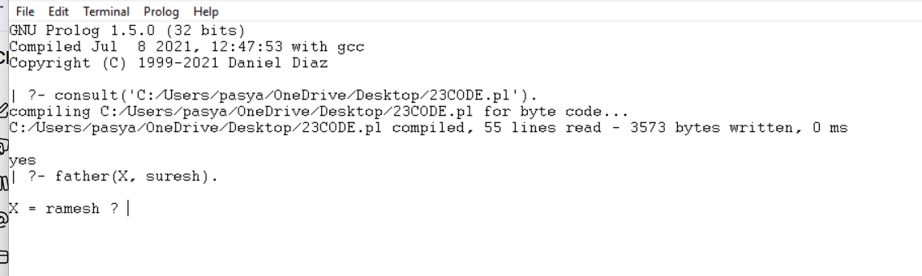
Result:
Thus, the family tree was successfully implemented in Prolog, and various family relationships such as father, mother, sibling, grandparent, grandfather, and grandmother were successfully determined using queries.

